GCSE MEDIA STUDIES 2013

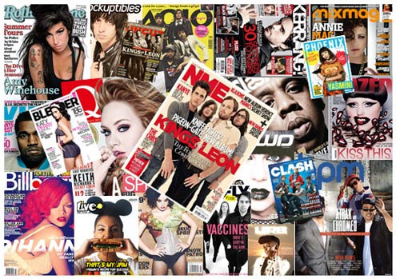

The Music Press Revision Guide
TARGET AUDIENCES

- Audiences can be identified in many ways e.g. through demographic research by Govt. Departments – the Population Census.

- Media institutions e.g. Music Magazines, the Advertising and Television Industry use this information when targeting/segmenting audiences

- Some Media organisations still use old fashioned socio-economic categorisation to estimate ‘notional spending power’

A – Land Owners, Royal Family
B – Doctors, Lawyers
C1 – Teachers, Nurses, Supervisors
C2 – Skilled manual
D – Semi-skilled/unskilled manual
E – Unemployed/Prisoners/Pensioners/Students

Q Magazine would have – B, C1 target audience (middle class/upmarket)
We Love Pop online Magazine would have a C2, D and E target audience (working class)

- An alternative categorisation = Psycho-Graphic research (Young and Rubican Advertising Agency, 1974) based on personality type.

Succeeders – think of themselves as powerful/in control (e.g. Mercedes Adverts)
Aspirers – want to improve/learn (e.g. Music Mags, Perfume adverts,)
Carers – have a social conscience (e.g. Charity Adverts)
Mainstreamers – prefer to be like other people (e.g. We Love Pop, Capital Radio)
Individualists – prefer to be different (e.g. Miami Ink, Specialist Magazines)

- No audiences are formed entirely on the basis of the above two ways – Demographics is the most detailed way of targeting an audience.

- Demographics is a much more sophisticated way of targeting audiences developing detailed criteria e.g.

Age | Geographical Location | Media Accessed
Gender | Lifestyle | Attitude
Sexuality | Religious Beliefs | Financial Status
National Identity | Marital Status | Body Shape
Social Class | Education
Race and Ethnicity | Family Background
Occupation | Hobbies and Interests
Income | Ability/Disability

General Certificate of Secondary Education
June 2013

Unit 1 Investigating the Media
Topic The Music Press: Print and Online

SAMPLE PAPER

Time allowed
1 hour 30 minutes

Instructions
- Use black ink or black ball-point pen. You should use coloured pencils, fine liners and a ruler whereappropriate.
- Write the information required on the front of your answer book. The Examining Body for thispaper is AQA. The Paper Reference is 48101.
- Answer all tasks.
- You should make sketches and diagrams to help develop your answers where appropriate.
- Do all rough work in your answer book. Cross through any work that you do not want to be marked.
- Label clearly your additional sheets. Make it clear which task each sheet relates to. Attach themsecurely to your answer book.
- You may not bring your copy of the Pre Release Material (48101/PM) or any associated materials tothis examination.

Information
- The marks for tasks are shown in brackets.
- All tasks carry equal marks.
- The maximum mark for this paper is 60.
- You are reminded of the need for good English and clear presentation in your answers. Quality ofwritten communication will be assessed.

Complete all tasks.

You should spend 45 minutes on Tasks 1(A) and 1(B) and 45 minutes on Tasks 2(A) and 2(B).

Task 1

Audience research suggests the circulation of Print Music Magazines is falling because:

- the internet has allowed for a diversification of online music magazines
- it is cheaper and easier to view magazines online
- convergent links online are more appealing to target audiences

How far do you agree that these are the reasons whymusic magazine circulation is falling?
Give examples to support your views. (15 marks)

Task 2

Bearing in mind the type of magazine we are looking for, let’s have your pitch for a new Pop magazine, available in print and online formats. You need to think about:

- target audience
- genre
- style and format
- representations
- synergy and convergence(15 marks)

Task 3

The Pop Genreis a commercially successful global genre which is widely promoted across a range of media: television, other magazines, the popular newspaper press, radio,websites and blogs. Why is your magazine likely to be successful?
(15 marks)

Task 4 (no option in actual exam)

EITHER

Just like the cover page of print music magazines, a key appeal of online music magazines is the homepage.Create the homepage for your new magazine. You should use the A4 design sheet enclosed.
(15 marks)

OR

Design and create a double page spread feature that will appear in the first edition of your new print version music magazine. You should use the A3 design sheet enclosed.
(15 marks)

END OF TASKS
MUSIC - INDUSTRY TERMINOLOGY Glossary of Terms

- Mainstream – artists that are signed to major record labels and whose music is distributed to mass, national and often international audiences. Mainstream music is normally associated with ‘safe genres’.

- Independent – artists who have more localised appeal and niche audiences and that utilise digital technologies to create ‘brand awareness’. Independent labels do not have access to extensive distribution networks.

- Production – the physical manufacture and recording of music by record companies, e.g. in studios or less technologically advanced locations (more independent artists).

- Distribution – the way music is delivered to artists in a way in which they can hear it e.g. CDs of via downloads. Distributors like HMV and Amazon have key commercial relationships with record companies.

- Exchange – commonly used terminology which means audience consumption: how the music/product is being received.

- Promotion – paid for communication informing the public about what is available e.g. television, online and poster advertising and also Music Festivals.

- Royalties – amounts of money paid to writers, musicians and composers every time a piece of music is ‘exploited’ (aired or broadcast). This limited amount can be between 10% and 15%.

- Multinational Conglomerate – large organisations whose business interests are global, utilising synergy and convergence and also cross media ownership.

- Monopoly – where one company dominates the market

- Oligopoly – where four or more companies dominate the market

- The Big Four – the four international record companies that dominate music distribution and form the oligopoly of ownership: Warner Music Group, Sony Music Entertainment, Universal Music Group, EMI Group.
- Globalisation – where music is distributed around the work through elaborate cross media networks

- Horizontal Integration – where one media company acquires another media company in the same sector e.g. a Major Music Publishers buys an Independent Record Label

- Vertical Integration – where the means or production and distribution are controlled by one company e.g. Sony

- Copyright – where intellectual ownership is guaranteed to an artist to avoid exploitation through piracy. It cannot be copied. Cover versions of songs are subject to significant copyright fees and royalties.

- Digital technologies – primarily this refers to how the internet has changed the industry including advertising through websites (star, fan, product, social networking, online distribution, streaming, legal and illegal downloading e.g. through YouTube (file sharing), access to music through social networking sites like MySpace and Facebook, online stores like ITunes and Spotify, online distributors like Ditto, access to music through mobile devices.

- Synergy – where two or more compatible products sell each other e.g. a film and a CD (8 Mile), Artists with Playstation, Star websites

- Merchandising – where the popularity of a music artists is manipulated through the sales of spin off goods e.g. T Shirts and associated clothing, Wrist Bands, Stickers, Badges, Mugs, goods purchased after gigs

- Cross media ownership – where companies have interest in a range of media e.g. Sony and Gaming, Film Distribution, Electronic (Media related) devices

- Media Convergence – where music is advertised using a range of media platforms but also becomes available on one platform, the internet. A good example of convergence would be bands appearing on TV shows.

- Web 2.0 – this refers to how INTERACTIVE WEBSITES like Social Networking sites have allowed music to ne shared virally (and for free) with audiences with similar interests.

Music Press Quiz

- What Pop Music magazine was launched in 2011?

- Top of the Pops
- We Love Pop
- Only Pop

- Why has Kerrang magazine hybridised in the last 5 years?

- It no longer sees itself associated with Metal.
- To reduce it audience and become more niche.
- To widen its target audience due to falling circulation.

- Print media circulation e.g. music magazines is falling because:

- Nobody is interested in music anymore.
- The internet and other digital media has significant, alternative competition in the promotion of music.
- They are too expensive and audience are more interested in other genres or magazines,

- An independent Fanzine is ‘independent’ because:

- It is not published by large conglomerates or organisations and focuses on one artist or one group of artists in particular .
- It does not carry any advertising.
- It only publishes articles about independent artists.

- The Music Press is important to the success or failure of an artist because:

- Without the Music Press an artist cannot gain success.
- It legitimises their status and promotes them to a wider target audience.
- No publicity is bad publicity.

- The cross media presence of a magazine is important because:

- The magazine and brand is made available to a wider target audience across a range of platforms, ensuring a greater and continued chance of success.
- Without a magazine being available cross media nobody will read it.
- The technological revolution has ensured that the Dance genre in particular makes use of a range of media platforms – if magazines do not adopt this approach they cannot cover this important music genre.

- What is the advantage of being published by a large conglomerate or organisation like Bauer?:

- You can also read the magazine in Germany where Bauer are based.
- A wider range of artists will be covered by the magazine.
- Additional funding, higher production values and a reputation for quality.

- A target audience who are described as niche are more likely to be reading:

- The Wire
- Q
- Top of the Pops

- Which of the following is an online only, internet zine:

- The Source
- Drowned in Sound
- MixMag

- The main source of funding for print music magazines is:

- Subscriptions
- Cover Price
- Advertising revenue

- Synergy:

- Is where two or more compatible media sell each other
- Is where similar artists appear in the same magazine
- Is where there are links to other media platforms

- Why to online magazines have so many obvious, convergent links?

- So artists who accesst he homepage can follow their own progress and career.
- To maintain the interest of an ever demanding, technology competent target audience who are seeking entertainment from a wide range of sources.
- Research into eb 2.0 suggests that only interactive media is important to consumers.

- NME has been described as both mainstream and independent – what does this mean?

- It is independently published but carries articles about mainstream artists – this is the contradiction
- It has too much advertising for a so called independent magazine and as a result does not cater enough for emerging artists
- It foregrounds indie music but from more established artists and is owned by a mainstream publisher – IPC Media

- An article about the latest X Factor winner is likely to appear more in Smash Hits (online) and Top of the Pops magazine. Why?:

- Most artists who have succeeded in the X Factor would be described as belong to the Pop genre
- Both magazines are owned by Simon Cowell.
- The BBC own the X Factor.

- A new music magazine must have USP (Unique Selling Point) because:

- All other magazines do the same
- It needs to offer audiences something similar and different so audiences recognise conventions but also remain interested.
- It must hybridise to survive.

NME Music Magazine print Deconstruction

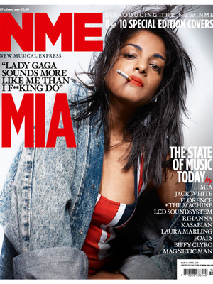

NME remains one of the longest running weekly music magazines in history after its initial publication in 1952. Originally the magazine was published in broadsheet newspaper format using newsprint , and competed for many year with titles such as Sounds (focussing on Rock and Heavy Metal genres) and Melody Maker (mainstream Pop and Chart music). Unashamedly ‘indie’ NME has always championed the cause of UK and US independent music and embraced Punk Rock in the 1970s and 1980s with an excitable fervour – alongside its clear musical preferences promoted by iconic writers such as Danny Baker and Tony Parsons (both now well respected cultural commentators) NME also did nothing to disguise its anti establishment, left wing socialist ideology. Campaigning artists like Billy Bragg and Paul Weller were frequently featured, particularly during the Thatcher era as part of the ‘Red Wedge’ movement.

In 1998 the ‘magazine’ became a magazine finally reverting to a colour magazine ink finish and printing in tabloid size format – ironically perhaps considering NME’s independent credentials it is now owned by international magazine publisher IPC, like Bauer Media Group part of the oligopoly of magazine publishers who in turn are owned by Time Inc whose parent company is Time Warner, the biggest media corporation in the world. Like the monthly magazine Q, it is again no surprise that its weekly circulation is low at 27,500, 60% down on 2003 figures and like every magazine and newspaper, suffering from the rapid decline in print media circulation as a result of the internet and new digital media. IPC still publish however 350 million magazines a year and their eclectic brands include Woman, Woman’s Own, Marie Claire. Wallpaper, Nuts and Horse and Hound. The brand of NME is itself iconic and as a result has survived its early competition in Sounds and Melody Maker. Commentators suggest there was always something that set NME apart and true to this www.nme.com, their online magazine has become critically and commercially successful (see below).

Cross media platforms are also promoted in the print version of NME with the website, like Q trading on the iconic, established brand name New Music Express (NME) itself having positive connotations of immediacy and being at the cutting edge of music evolution which was on many occasions the case - NME can probably lay more legitimate claim than other music magazines to being responsible for kick starting many career. NME have their own radio station but like Q, NME TV shut down in 2012 as a result of high production costs, fierce completion from other music channels and the continued success of YouTube and Vevo. After Punk in the 1990s NME adopted the Brit Pop and ‘Madchester’ scene with bands like Oasis and later adopting Blur, deliberately setting both against each other on NME covers as ‘northern, working class beer boys’ (Oasis) versus ‘southern, middle class, educated art students’ (Blur). The rivalry boosted magazine circulation, the band’s publicity and for most associated with Brit Pop (including ex Prime Minister Tony Blair) it was a win win situation. NME had been in on the birth of punk and now they adopted a critically and commercial successful (in the US) British music movement.

In the 2000s NME began to adopt a more hybridised format to keep pace with the proliferation of the music scene and electronic technology – artists like Jay-Z, Missy Elliott and and Aphex Twin were foregrounded but their inclusion brought considerable opposition from readers who reacted in the same way when a non indie, guitar based artist (Jay-Z) headlined at the Glastonbury Festival on Saturday night in 2008. This hybridisation and approach was withdrawn and the magazine reverted to its familiar format in terms of content. This realignment was more successful in 2001with NME adopting another raft of successful artists representing a new indie punk movement. Bands like The Strokes, The Vines, The White Stripes and later on The Libertines, Franz Ferdinand, The Kaiser Chiefs and the Artic Monkeys were the darlings of NME covers going on to become successful artists in their own right. A rebrand in 2008 saw the magazine targeting an older readership become less ‘poppy’ in its format and layout and focussing on ‘serious’ and critically successful bands like Coldplay.

The May 2010 edition above is typical of the current approach of NME – ‘NME’ appears as bold, upper case, red, sans serif block text on the left hand side top of the magazine with it stereotypical connotations of masculinity. Opposite the title but still in the masthead a main cover line states ‘Introducing the new NME. 10 special edition covers’ reflecting another mini rebrand. The cover is minimalistic in design and frames female artist M.I.A. centrally in medium shot as the USP (unique selling point) of the cover with her name as a bigger size font and same colour as the name of the magazine. Although on first glance this would suggest a departure from NME standard representations her inclusion and importance reflects the history of the magazine musically and politically – M.I.A’s music combines elements of electronic, Dance, alternative, World Music and Hip Hop but she cites punk as one of her key influences, particularly Malcolm McLaren and The Clash. M.I.A. also represents a positive representation of gender and multiculturalism which again fits the left wing, socialist political ideology the magazine has always been associated with. She is of Sri Lankan Tamil origin and fiercely considers herself British as evidenced by her dress code wearing a Union Jack top. Her body language is strong and positive suggesting a post feminist icon status which is anchored by the cover live underneath the title, ‘Lady Gaga sounds more like me than I f**king do’. Lady Gaga, in terms of her representation would also be considered a post feminist icon.

M.I.A’s body language is almost aggressive and confrontational as she stares back at the camera smoking a cigarette challenging the target audience. Although pluralistic in her representation there are still elements of the photograph (a photo shoot for this cover) that suggest she is also sexualised and framed for the male gaze. This would successfully appeal to the magazines demographic which would primarily include ABC1, Individualists and Aspirers , urban and city living, 16-35, male skew but with a significant secondary female readership. The lower price of this weekly magazine is also likely to reflect a younger reader and the audience would also respond to the simplicity in terms of graphic design of the front cover with a basic colour palette of reds, blues and white; use of non standard English on the cover would also have the same effect. For most NME readers however content would be more important than design as cultural capital and intelligent knowledge and understanding of the music industry are important factors. The bottom right cover line, ‘THE STATE OF MUSIC TODAY’ suggests an authority that the magazine feels qualified to comment on with contributions interestingly by artists from a range of genres and not exclusively indie including Rihanna (Pop) and Laura Marling (Folk). Foregrounded however at the top of the list includes more traditional NME artists such as Jack White and Florence and the Machine suggesting their perceived hierarchy and status within the music industry.

NME Online Music Magazine www.nme.com Deconstruction

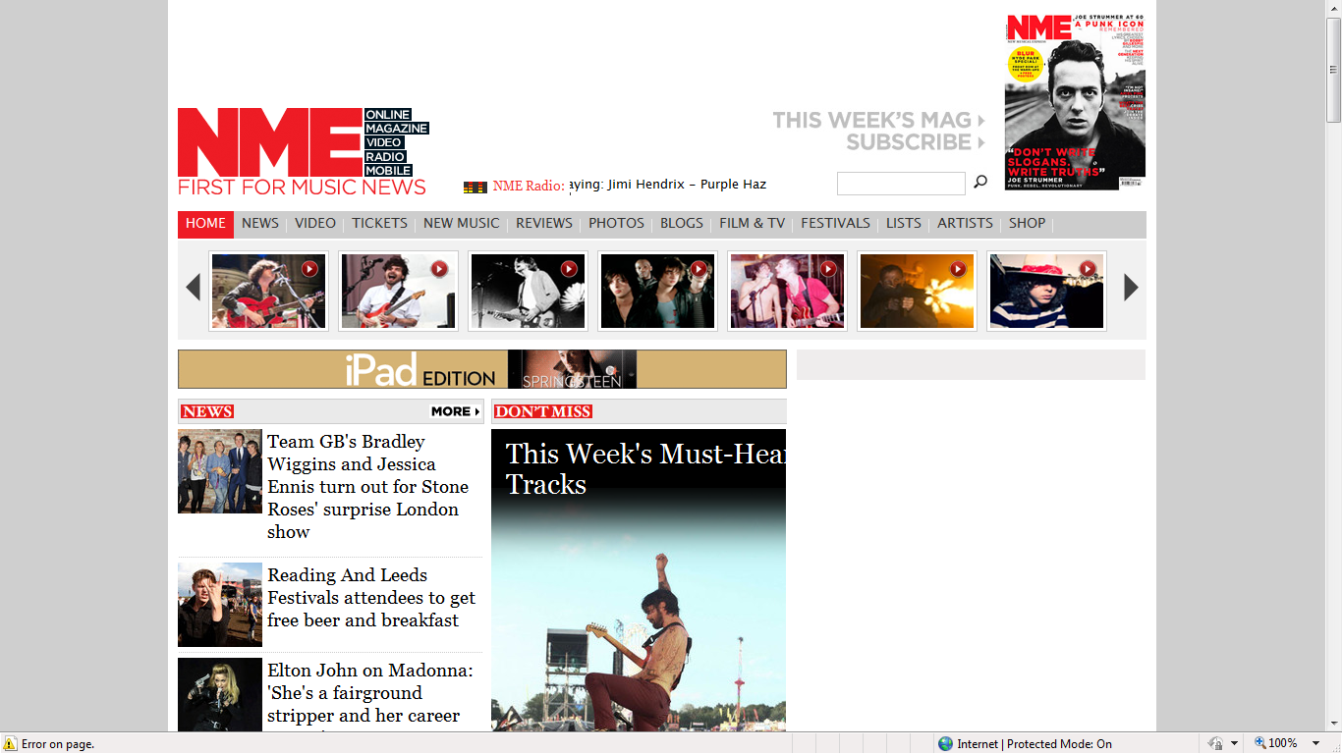

Nme.com was first established in 1996 and quickly achieved critical and commercial success to now be widely regarded as the world’s most successful stand alone online music magazine attracting up to 7 million users per month. They initially specialised in ‘firsts’ just like NME print music magazine was the first to run a singles chart – in 1999 nme.com streamed a live webcast of Suede playing live in Japan. In 2007 the brand of NME launched a USA version of nme.com reflecting the proliferation of American indie punk bands like The Strokes whose music borrows heavily from the tradition of British punk. Throughout the 2000s and into the 2010s nme.com continually attracted attention winning a range of awards from the BT Digital Music Award for Best Music Magazine in 2008 to the PPA (Periodical Publisher’s Association) Interactive Consumer Magazine of the Year Award in 2009. New media and embracing digitisation has always been important to nme.com with a range of convergent links into television, film and other audio platforms. A sister sire was launched in 2011with the URL www.nmevideo.com which potentially was one of the reasons why NME TV no longer needed to carry on broadcasting. Digital line extending of the NME brand has continued into NME Festivals Blackberry sponsored SmartPhone app and the inevitable iPhone app. Later on that year another first for nme.com saw a live blog of Twitter users listening to the Nirvana album ‘Nevermind’ celebrating its 20 year anniversary.

The leaderboard of nme.com above encodes a familiar title in a recognisable house style using the same style of font, colour and placement. Underneath the brand named NME however is a tagline ‘FIRST FOR MUSIC NEWS’ signifying nme.com’s reputation as being ‘first’ with music industry breaking news and cutting edge in their format. Content analysis of the website does reveal an in depth amount of news stories both above and below the fold reflecting the informative, almost exclusive mode of address of the magazine. Next to the title is found in the leaderboard convergent links but flagged up and advertised before they are normally found as links including ONLINE, MAGAZINE, VIDEO, RADIO, MOBILE evidence the clear focus on cross media digital, interactive platforms. In the middle of the leaderboard this cross media focus is anchored by a simple link to NME Radio informing audiences of which track is playing. The final right hand section of the leaderboard is inevitably a subscription link to NME print music magazine recognising the authority and originality of the paper based version.

Convergent links as a common homepage convention run alongside, and directly underneath the leaderboard containing a broad range of options including Video, Tickets, Reviews, Photos, Blogs, Film and TV, Festivals, Lists, Artists and Shop (merchandising opportunities). Underneath this is a horizontal banner with inset pictures (as links) evidencing synergy linking to the James Bond Skyfall trailer and a range of iconic artists. The top of the homepage is able to offer high impact with the contents of the leaderboard itself, convergent links and further inset pictures allowing users to engage in audio visual content without having to scroll further down the page. ‘News’ as again a common convention continues to scroll down the left hand side of the page, juxtaposed with plenty of web 2.0 use of white space (at times the online magazine has the feel of a social networking site encoding connotations of inclusivity).

Advertising makes direct linking with a older and younger target audience comfortable with digital technology and further evidences synergy by encouraging users to download Springsteen tracks via the corporate giant iTunes which would provide significant revenue for the online magazine. Artists with similar longevity and as established or historical are referenced continuously including Joy Division, David Bowie and The Smiths – this serves to arouse the cultural capital of younger audiences into retro culture but also generate interest from older audiences. Underneath these links are ever more filmic links and also popular culture links including sport (nme.com is very interested in film culture and the relationship between film and music including ‘The Two Door Cinema Club’. Stories links carefully with the Olympics in terms of style with news of Bradley Wiggins and Jessica Ennis attending a Stone Roses concert (the magazine does not harm itself by being associated with Olympic success and both athletes are seen as the male and female pin ups of Team G.B. Another story announces Weller and Wiggins as ‘The Mod Couple’ which makes intertextual links to the 1968 Hollywood film with Jack Lemmon and Walter Matthau but allows nme.com to associate the trendy Fred Perry wearing Wiggins with mod culture as linked with ex The Jam front man and now successful solo artists and apparent ‘Modfather’, Paul Weller.

Below the fold on nme.com’s homepage is unusually busy and allows users to easily navigate to an array of video links and more news items and also concert ticket purchase. Further down are found more film links and also reviews suggesting that despite its uncluttered layout, interactive, convergent links to a raft of rich media is important to users.

Mini Glossary of Magazine Terms

- Mainstream: Standardised, conventional media representations – normally associated with commercial success rather than critical success.

- Independent: Media texts that are consumed by smaller, more niche audiences and not normally associated with large companies or organisations.

- Left wing, Socialist ideology: An overarching belief system (ideology) that champions the causes of the individual and minority groups against mainstream culture and big business.

- Tabloid: A smaller sixed newspaper format used by The Sun for example.

- Critical success: Where success is measured by awards and reviews.

- Commercial success: Where success is measured by how much money a piece of media makes.

- Rebrand: Where a new image is given to a media text.

- USP: Unique Selling Point – where a media text is sold to audiences on the strength of something specific.

- Multiculturalism: The positive foregrounding of the diversity of race and ethnicity.

- Iconic: Something that is well known and has established status.

- Masthead: Normally the top, or main strip or bar across a magazine.

- Conventions: The expected aspects of a media text, normally associated with genre.

- Signify: Where meaning is constructed though signs and symbols.

- Connotations: Similar to signifies, connotation is where something has an implied meaning from the denoted signs and symbols associated with it.

- Tagline: The saying or textual association of a magazine.

- Encodes: Media producers (or publishers) encode or put in meaning.

- Mythical: Something in the media that has the status of accepted truth but which in fact has been constructed to give this impression.

- Genre: Type or Sort.

- Cultural Capital: The pre existing knowledge, skills and experience an audience have that affect their reading or deconstruction of a media text.

- Oligopoly: Where four or more companies, e.g. magazine publishers like Bauer dominate the marketplace.

- Circulation: The amount of copies of a magazine that is sold or is given out.

- Cross Media Platforms: Where a media text or brand has a presence in a number of different media.

- Brand: The image or association of a named product.

- Demographic: An in depth analysis of the target audience covering a range of criteria.

- Advertising Spend: How much money is spent on advertising.

- Hybridised: Where the conventions of two or more genres are apparent.

- Framed for the Male Gaze: Where a subject is set within the frame (e.g. a magazine cover) and is sexualised for male audiences (from Laura Mulvey’s male gaze theory).

- Advertising Revenue: How much money a magazine, for example makes from advertising.

- Anchor: When something is ‘anchored’ it has a definite meaning.

- Stereotypical Connotations: Something that audiences expect but that is often based on limited information.

- Aspirational: Audiences look up to something or somebody.

- Foregrounded: Where an image or person is put at the front of audiences’ minds.

- Mode of Address: The way a media text speaks to its audience.

- Minimalistic: Lacking depth and detail.

- Pun: Use of double meaning.

- Colour Palette: An overall colour scheme.

- Leaderboard: The online equivalent of a masthead.

- Navigation: How audiences or users move around a website.

- House Style: A recognisable style e.g. from print magazine to online equivalent.

- Interactive: Where audiences take an active part in a media text and where communication is two way and not one way.

- Typography: An overall term used to describe the physical representation of text.

- Font: The style of the lettering.

- Hierarchy: An agreed status or chain of command/authority.

- Digital: New media/forms of technology across different media platforms.

- Retro Culture: Where audiences enjoy culture from years gone by.

- Above the Fold: The top half of a homepage.

- Below the Fold: The bottom half of a homepage.

- Convergent Links: Interactive links to other media.

- Merchandising: The spin off sale of associated goods and services.

- Synergy: Where two or more compatible forms sell each other.

- Juxtaposition: Where something is deliberately placed next to something to create a third meaning.

- Pluralistic: A representation that is challenging, more contemporary and diverse and resists stereotyping.

- Post Feminist Icon: A female representation where the subject exhibits both stereotypical male and female characteristics.

- Line Extending: Where the authority of an existing brand is used to diversity into different products.

- Intertextuality: Where one media text makes reference to another.

- Rich Media: Links to a broad range of cross media platforms.

- Web 2.0: A more interactive layout on a web page commonly associated with social networking sites – less of a one way form of communication.

- Popular Culture: Media normally consumed by mainstream, mass audiences.
Q Music Magazine print Deconstruction

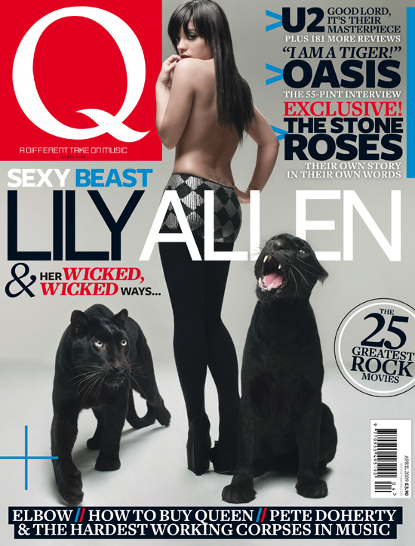

Audience identification with the iconic, recognisable masthead first appeals to consumers – taking up 15% of the front cover an enigmatic, upper case, bold, white on red, block serif letter ‘Q’ is a box on the left hand side top of the cover. This departs from the conventions of magazine covers that normally run a masthead run along the top of the front cover. ‘Q’ is enigmatic, just like the regular Spine Line which changes every months because many readers will be uncertain why it is called by this name and according to the Editor it looks original and displays better on newsstands (the magazine was planned to be called ‘Cue’ as in cue the music but it was thought there was an outside chance it could be mistaken for a snooker magazine, a sport which was very popular when Q launched in 1986. The white letter could signify simplicity or purity while a red background has connotations of danger – the founders of the magazine thought at the time that the music press was ignoring older, primarily male music buyers.

Within the masthead, the magazine’s tagline is foregrounded – ‘A DIFFERENT TAKE ON MUSIC’. This again encodes a sense of originality and almost ‘independence’ to audiences which is in fact mythical if audiences engage in content analysis; Q magazine devotes a significant amount of content to established, mainstream Rock artists and belongs to the Rock genre frequently running articles on its favourite British bands including the Rolling Stones, Stone Roses and Blur. ‘A DIFFERENT TAKE ON MUSIC’ however is another successful way to market to audiences who perhaps do not have the significant cultural capital of the primary reader.

Q magazine has high production values and this is evidenced by its glossy, monthly format and also by fact that it is published by the Bauer Media Group, one of the oligopoly of magazine publishers who acquired EMAP in 2008. Bauer own 282 magazines in 15 countries and also TV and Radio stations and are the UK’s largest publishing group. It is with this financial backing that Q can sustain relatively low monthly circulation of 80,400, as with most other consumer magazines a common occurrence with many diversifying into new media as with Q’s website www.qthemusic.com. Bauer’s other music magazine titles include Mojo and Kerrang who, like Q have diversified into cross media platforms like Q TV and Q Radio. The Q Awards are also sponsored by the brand (though Bauer) and remain one of the UK’s most prestigious music awards. It with this in mind that Q sees itself as more sophisticated than other titles offering quality and still attracting high profile advertisers despite the low circulation. Q’s demographic have a high potential for advertising spend suggesting ABC1, aspirers, male skew, urban and city living 25-45 who are ‘into their music’.

Q have hybridised up to a point with the Rock genre very much apparent but with a focus occasionally on quality indie artists like Pete Doherty and Elbow. Q want to be associated with successful music artists and a way of maintaining their place in the market is by flexibility in terms of genre (see also Kerrang magazine). Guitar bands are Q’s main focus and as a result have a close relationship with the Glastonbury Festival producing a free daily newspaper during the festival although as with the above front cover are comfortable with running covers devoted to popular female artists who are invariable framed for the male gaze with this audience in mind. In April 2010 Q caused controversy when they ran a front cover featuring Lady Gaga, centrally framed in medium shot covering her breasts, only to be banned by some US retail outlets. Unashamedly ‘boysey’ Q’s sister papers include Empire, a wholly mainstream, male dominated film magazine and football magazine FourFourTwo.

Q are also well known for compiling ‘lists’ – on the above front cover a typical example of this would be cover line ‘The 25 Greatest Rock Movies’ and have an extensive ‘Review’ section (new releases, reissues, live concert reviews and film). Q TV closed in July 2012 but again focussed on Rock videos and Rock films with the occasional indie and ‘alternative’ reference. The saturation of music TV channels and low viewing figures made it untenable that it continue broadcasting. Q Radio however continues and is available on the internet, on digital radio or on digital television networks with the added advantage of limited production costs while the cost of maintaining Q TV was considerable and without enough advertising revenue to cover costs. As with the print music magazine, the brand Q remains recognisable, but for how long?

Cover lines on the right hand side of the above edition anchor the masculine representations with not only bands like U2, The Stone Roses and Oasis having hyper real, stereotypical connotations but the lettering also appears in bold, upper case, sans serif block with its own signification of masculinity. All bands are British and entirely male with all Oasis and The Stone Roses conforming to a hell raising, bad boy image which would be read as aspirational by much of the target audience who are fans of the groups. U2 are foregrounded as a dominant, successful global band with their lead singer Bono often revered and enigmatic. The sub headings ‘Good lord, it’s their masterpiece’ and ‘The 55 pint interview’ again serve to anchor these hyper real masculine associations that the readers expect. The mode of address is used to facilitate this with the magazine talking directly to the reader in an informal way with common use of exclamation marks creating the myth of a personal communication. This is s similar technique uses by Men’s Lifestyle magazines to create a form of inclusivity like the readers are all part of the same homogenous group.

This simplistic, almost minimalistic front cover suggests the sophistication that Q magazine are looking to achieve – many lower production value magazines have cluttered from covers that have limited design considerations. The central image, Lilly Allen is a carefully constructed photo shoot ensuring the singer appear frames centrally in long shot, topless looking back at the male audience. Her body language, including a hand on hip, her seductive gaze, and dress code including black tights, heels and hot pants are straight out of a Men’s Lifestyle magazine and are common conventions. Across her body the main cover line, ‘SEXY BEAST LILY ALLEN’ has its own connotations and could be understood as a pun with the presence of two black Panthers flanked to either side. Wild cats stereotypically are associated with a sexual connotation (sleek, dangerous, uncontrollable, deadly but beautiful) and are used in this way on the front cover. Again written in sans serif font her name is foregrounded large as a banner and the colour palette is also stereotypically masculine using silvers, blacks, whites and reds which also serve to create more of an aesthetically pleasing cover. Written underneath Lily Allen’s name in smaller, italicised this time red for passion and danger upper case text is use of alliteration ‘WICKED, WICKED WAYS’ which allows audiences to decode the impact of the sexual representation through use of language.

The cover lines that run along the bottom of the front cover signify their importance in terms of genre in that are mainly indie compared to the main cover lines about Rock bands at the top right of the page. Pete Doherty’s on and off drug dependency is referred to by the cover line ‘PETE DOHERTY AND THE HARDEST WORKING CORPSES IN MUSIC’ but a hyper real masculine representation is still apparent as like the other Rock artists he has a bad boy image. The only female frame of reference on the front cover is an overtly sexualised Lily Allen whose presence is for male audiences and potentially for a secondary female target audience who could see her as an aspirational role model. Her agreement to appear on the front cover of Q is an interesting one from a marketing perspective as lyrically many of her songs reflect a fierce independence but arguably the cover image references the significant other (men) that her songs do not – this would be a mutually beneficial marketing agreement both for Q and Lily Allen as with the Lady Gaga front cover, both would benefit from notoriety and publicity while Q remain associated with quality artists.

Q Online Music Magazine www.qthemusic.com Deconstruction

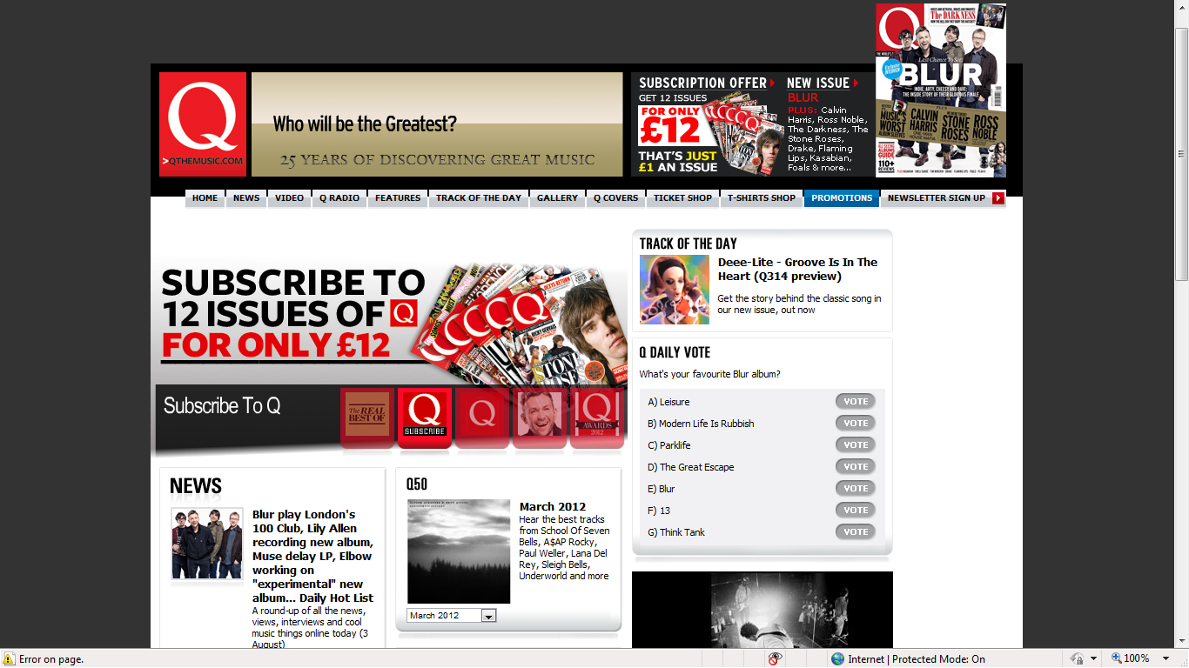

Q’s online music magazine, www.qthemusic.com makes continual reference to the established brand that is Q Magazine – much of the homepage is devoted to the print version with subscription offers found in the leaderboard and with an option of a hero shot which is a larger image of the subscription advert. It would be safe to say that this particular online magazine relies on the iconic print version which it regularly pays homage to. On the homepage, qthemusic has the significant advantage of immediate navigation and audio visual links and it is constructed in such a way as to be subservient to the dominant print product despite its millions of page impressions and hits compared to the low circulation of Q magazine.

The leaderboard boasts the same house style as the print magazine masthead by having the letter Q positioned top left using the same typography and colour palette but without the tagline, ‘A DIFFERENT TAKE ON MUSIC’ – this allows online consumers to focus more on the interactive elements which are not so apparent in the printed version. Next to the magazine title the interactivity starts with the rhetorical question ‘Who will be the greatest?’ Written underneath it states ’25 YEARS OF DISCOVERING GREAT MUSIC’ suggesting optimistic ambition to be responsible for the success of more artists than is probably the case. ‘Who will be the greatest’, as with the colour palette of red and the font used in the masthead conforms to a house style in Q magazine that as previously identified is keen on list generation e.g. 100 best songs, videos or albums. This list generation also creates a hierarchy and allows the magazine, both in print and online formats to take an opinionated, subjected but informed analysis on the Rock, indie and ‘alternative’ music scene.

The use of rhetorical question and indeed list generation conforms to masculine stereotypes of challenge and recording of information for purposes of historical documenting. This is one of the biggest challenges to qthemusic, to reference history and tradition but within a digital, interactive media format. With this in mind the online music magazine still has a male skew with ABC1, aspirers, urban and city living but has a younger demographic. Again stereotypically, older men tend to collect magazines and buy vinyl and CDs while younger audiences use new media and download music. The website caters for both and it is worth recognising again that this is a stereotypical assumption – retro culture is very popular among young target audiences and Rock and older indie bands like the Stone Roses, frequently foregrounded by Q move carefully into this equation. To support this, still in the leaderboard within the smaller Q subscription advert the rock and indie bands Blur, The Darkness and The Stone Roses are advertised as being in the latest edition, all established and historical bands with their better years behind them. Also included are Kasabian, an indie Rock band, Drake, a Hip Hop artist (perhaps acknowledging the younger online audience) and British comedian Ross Noble, himself a surreal but stereotypically masculine character who would conform to the traditional gender skew offered by the brand, Q.

The layout of the website is minimalistic, similar to the printed magazine itself but traditional to many homepages i.e. boxy and with little variation of font – significant amounts of white space are above the fold and below the fold (more below the fold as most of the information viewed on homepages is on the top half of the homepage) making navigation straightforward and simplistic. Convergent links on the leaderboard allow users to navigate to landing pages containing a variety of rich media and additional audio-visual content including News, Video, Q Radio, Features, Track of the Day, Gallery , Q Covers (again reinforcing the dominance of the printed magazine), Ticket Shop, T Shits Shop (an an example of B2B merchandising), Promotions and Newsletter. All the above links reflect the interactive nature of qthemusic with more added value but without a glossy magazine in their hands. The homepage has much lower production values but is able to synergise with Q Radio, link to an archive thus reinforcing the brand, offer instant tickets, photo galleries and merchandising all appealing to a younger demographic. As an online Rock magazine qthemusic is less interactive than www.welovepopmag.co.uk and www.toppmag.com as although targeting a younger audience than Q magazine the users are likely to be more ‘serious’ about music and less likely to need to be entertained by non relevant interactive links.

The hero shot is traditionally placed underneath the leaderboard and is simply a larger advert for Q magazine inviting users to subscribe with inset images of back copies – this branding reinforces the arguably opinionated approach the brand has by promoting itself and not an artist on the main image on the homepage. Next to the hero shot is further evidence of Q’s subjective, opinionated approach to reviewing with ‘Track of the Day’ and ‘What’s your favourite Blur album?’ This interactivity encourages users to identify with a band that is frequently featured within the covers of Q, thus reinforcing the magazine’s own mediated representation of the music industry. This mediation however is tempered with a clear understanding of the target audience and an awareness of their needs and wants. Again, good use of white space enables users to navigate above the fold to the next two sections which again ensure interactivity with past news and editions but also a substantive section, ‘News’ which runs along the left hand side of the home page and extends right down from above the fold to below the fold – news items offer 3 or 4 lines of emboldened text to attract the target audience followed by 3 or 4 more lines of text with the opportunity of clicking through to the extended story. This assumes a certain level of knowledge in relation to the target audience and allows them to utilise their cultural capital in relation to choice of story. Stories and news as of 6th August 2012 included Morrissey balking at the “blustering jingoism” of the Olympics encoding up to a point a preferred reading that Q are a bit trendy and anti establishment which would be aspirational with some of their ‘political’, more left wing readers. Three other stories make reference to Blur, one to icon Bruce Springsteen and another offering tickets to see another ‘grandfather’ of rock, Lou Reed. As identified earlier, association with established stars remains important to qthemuisic.

Further convergent links to Q Radio again develop a cross media approach to continuing the brand image of Q while the right hand side of qthemusic has a larger amount of white space below the fold reflecting the lack of navigation of this part of homepages by users. It terms of design and layout what it also serves to generate is visual interest in the news column as it is juxtaposed to nothing. Qthemusic normally runs skyscraper adverts along both sides of the homepage and relate directly to the target audience in terms of their gender e.g. adverts for Whiskey which stereotypically is a spirit drunk by older male consumers.

Mini Glossary of Website Terms

- Audience Identification: Where audiences are familiar with an element through repetition and expectations.

- Iconic: Something that is well known and has established status.

- Masthead: Normally the top, or main strip or bar across a magazine.

- Enigmatic: Something that makes readers engage with a text by asking questions.

- Serif: A stylised type of font.

- Conventions: The expected aspects of a media text, normally associated with genre.

- Spine Line: Text written along the spine of a magazine.

- Editor: The person responsible for the content and overall layout of the magazine.

- Signify: Where meaning is constructed though signs and symbols.

- Connotations: Similar to signifies, connotation is where something has an implied meaning from the denoted signs and symbols associated with it.

- Tagline: The saying or textual association of a magazine.

- Encodes: Media producers (or publishers) encode or put in meaning.

- Mythical: Something in the media that has the status of accepted truth but which in fact has been constructed to give this impression.

- Genre: Type or Sort.

- Cultural Capital: The pre existing knowledge, skills and experience an audience have that affect their reading or deconstruction of a media text.

- High Production Values: Where a magazine, for example suggests evidence of significant funding.

- Oligopoly: Where four or more companies, e.g. magazine publishers like Bauer dominate the marketplace.

- Circulation: The amount of copies of a magazine that is sold or is given out.

- Cross Media Platforms: Where a media text or brand has a presence in a number of different media.

- Brand: The image or association of a named product.

- Demographic: An in depth analysis of the target audience covering a range of criteria.

- Advertising Spend: How much money is spent on advertising.

- Hybridised: Where the conventions of two or more genres are apparent.

- Framed for the Male Gaze: Where a subject is set within the frame (e.g. a magazine cover) and is sexualised for male audiences (from Laura Mulvey’s male gaze theory).

- Mainstream: Where a media text contains standardised, expected content and is usually consumed my mass audiences.

- Saturation: Sometimes, a magazine market can be ‘saturated’ – this means there are lots of similar texts.

- Advertising Revenue: How much money a magazine, for example makes from advertising.

- Anchor: When something is ‘anchored’ it has a definite meaning.

- Hyper Real: An exaggerated representation.

- Stereotypical Connotations: Something that audiences expect but that is often based on limited information.

- Aspirational: Audiences look up to something or somebody.

- Foregrounded: Where an image or person is put at the front of audiences’ minds.

- Mode of Address: The way a media text speaks to its audience.

- Homogenous: Where a group has similar characteristics.

- Minimalistic: Lacking depth and detail.

- Pun: Use of double meaning.

- Colour Palette: An overall colour scheme.

- Aesthetically Pleasing: Where a media text has a pleasing look.

- Alliteration: Three or more consonants used in sequence for effect.

- Leaderboard: The online equivalent of a masthead.

- Hero Shot: The main image on a homepage, above the fold.

- Navigation: How audiences or users move around a website.

- House Style: A recognisable style e.g. from print magazine to online equivalent.

- Interactive: Where audiences take an active part in a media text and where communication is two way and not one way.

- Rhetorical Question: A question that does not require an answer.

- Typography: An overall term used to describe the physical representation of text.

- Font: The style of the lettering.

- Hierarchy: An agreed status or chain of command/authority.

- Digital: New media/forms of technology across different media platforms.

- Retro Culture: Where audiences enjoy culture from years gone by.

- Surreal: Something that resists the obvious construction of meaning and that can be strange and unusual.

- Above the Fold: The top half of a homepage.

- Below the Fold: The bottom half of a homepage.

- Convergent Links: Interactive links to other media.

- Landing Pages: Where audiences end up after clicking through a link.
- B2B: Business to Business – online marketing between businesses.

- Merchandising: The spin off sale of associated goods and services.

- Synergy: Where two or more compatible forms sell each other.

- Mediation: Where information or culture is constructed in a certain way to reflect the media producers’ point of view.

- Preferred Reading: The intended meaning encoded into a media text.

- Skyscrapers: Adverts that run down the side of a web page (and that look like skyscrapers).

- Juxtaposition: Where something is deliberately placed next to something to create a third meaning.

